**Water Meters:**

**1 Mechanical water meters**

**1**

**Smart water meters**

**2**

**M1**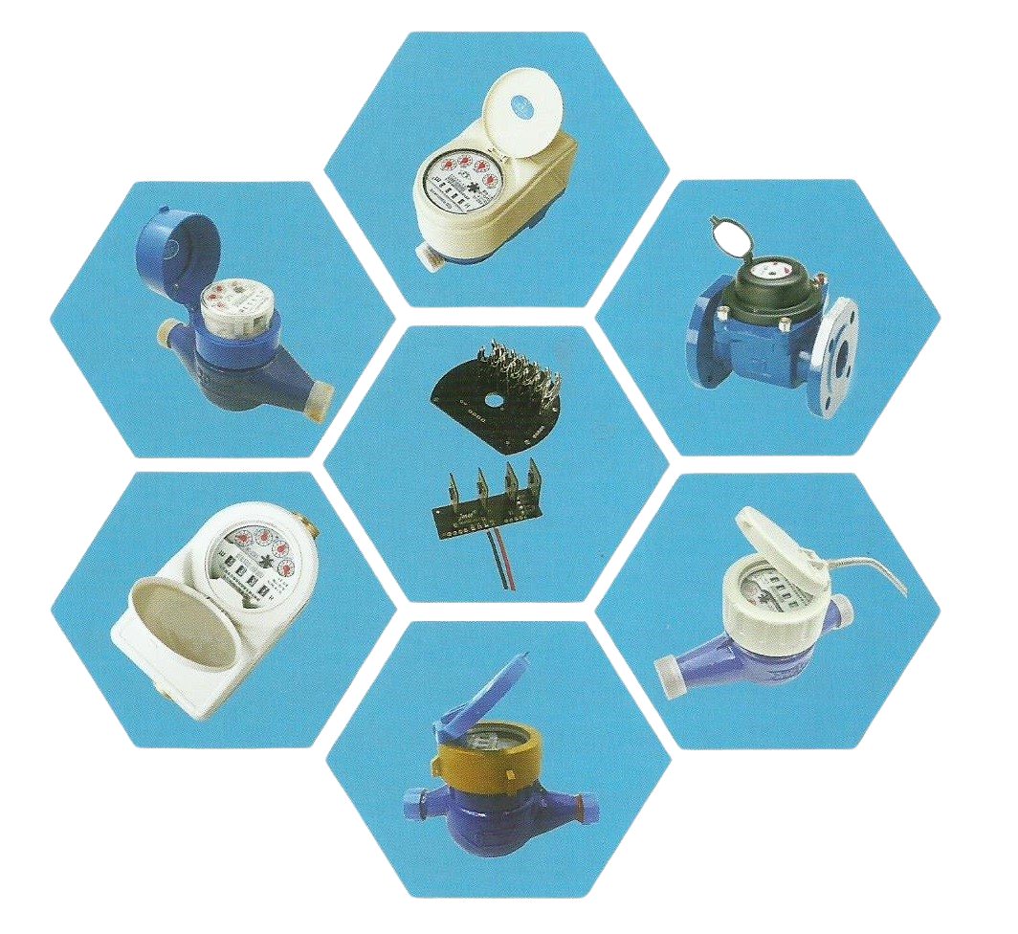

**Mechanical water meter**

**Single jet water meters**

**Multi jet water meters**

**Bulk water meters**

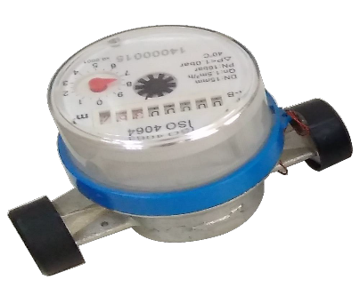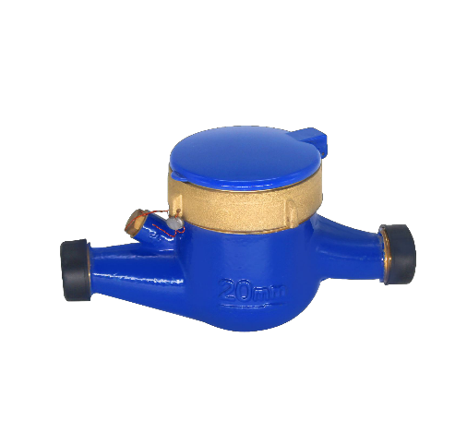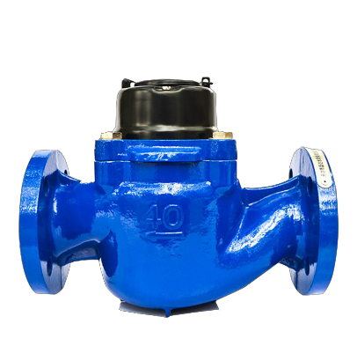

* 15~25 water meter
* Brass water meter (DN15 ~ DN50)
* Plastic water meter (DN15 ~ DN25
* DN40 ~ DN200

**Smart water meter**



**Prepaid water meter**



**LORA water meter**

**NBIOT water meter**

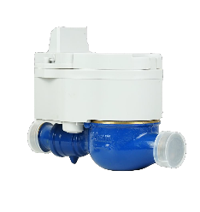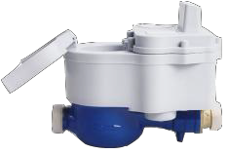

**LoRaWAN water meter**

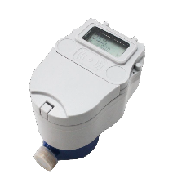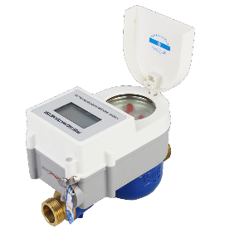

**RS485 remote water meter**

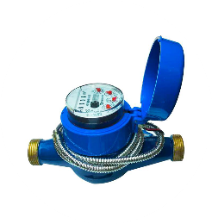

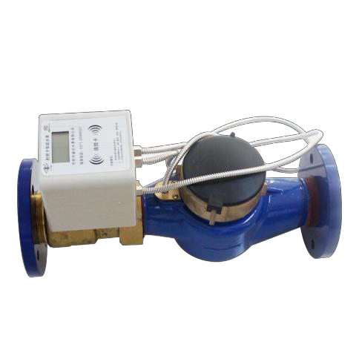**Prepaid water meter**

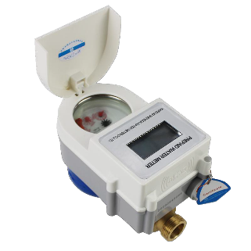

* DN15 – DN300
* Automatically control the water consumption according to the contract, automatically finish the ladder water price calculation
* Composed of a water meter with a transmitting device, RF radio frequency card as a data carrier, and a meter and an electronic control valve.

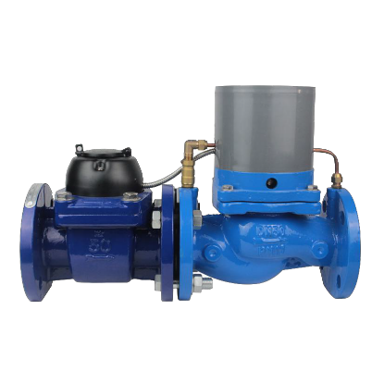**LoRa water meter**



* DN15 – DN200
* LoRa remote reading smart water meter, make use of LoRa transport technology
* Change mechanical water meter's calculate message to electric signal and storage
* Wireless remote reading water meter smart water meter
* control valve automatically
* Can also use datalogger in hand to software and network
* The wireless remote meter is composed of wireless communication module and base water meter
* It has the functions of measurement, operation, storage, diagnosis,
* control valve, wireless remote transmission and so on

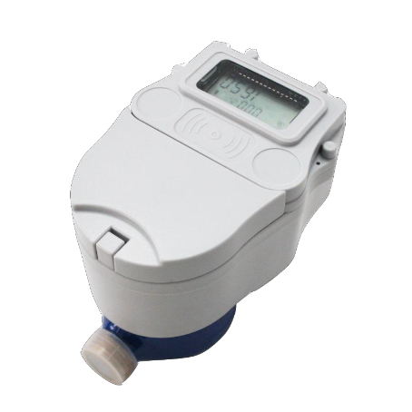**NB-IOT water meter**

* DN15 – DN200
* With the wide application of new technologies such as Internet of Things and cloud computing, smart water based on NB-IoT technology will become one of the indicators of the level of information management in smart cities
* NB-IoT module adopts high-performance low-power NB-IoT cellular narrow-band network technology, and its signal network has depth coverage (the ground table well, pipeline well, etc. can be used normally), ultra-low power consumption, stable and reliable communication,
* Use Authorized narrowband 4G network transmission without the need to build a base station
* Realized post pay and prepaid function

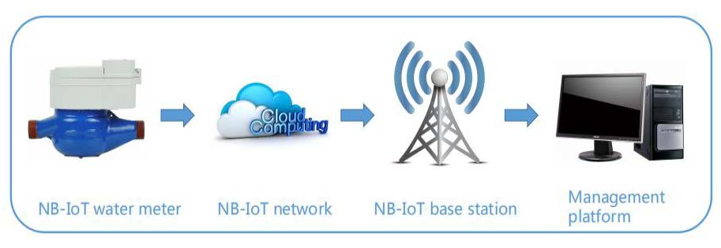

**LoRaWAN water meter**

* Lora WAN smart water meter is a self-developed smart water meter based on Lora WAN communication.
* It has functions such as water measurement, valve control, remote monitoring, etc.,
* Uses LoRa modulation technology, follows Lora WAN wireless transmission protocol, and works with Lora WAN gateway to achieve remote monitoring or Smart management.

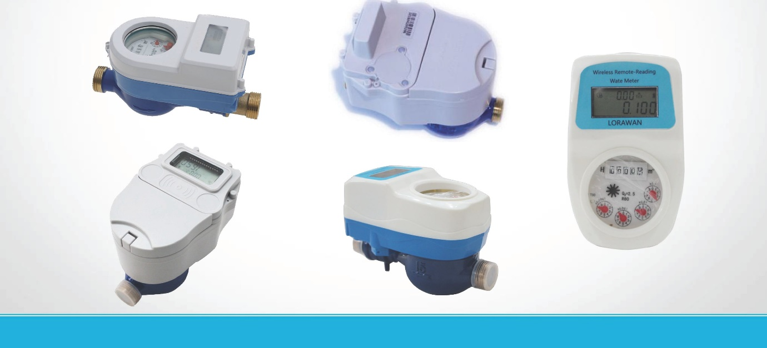

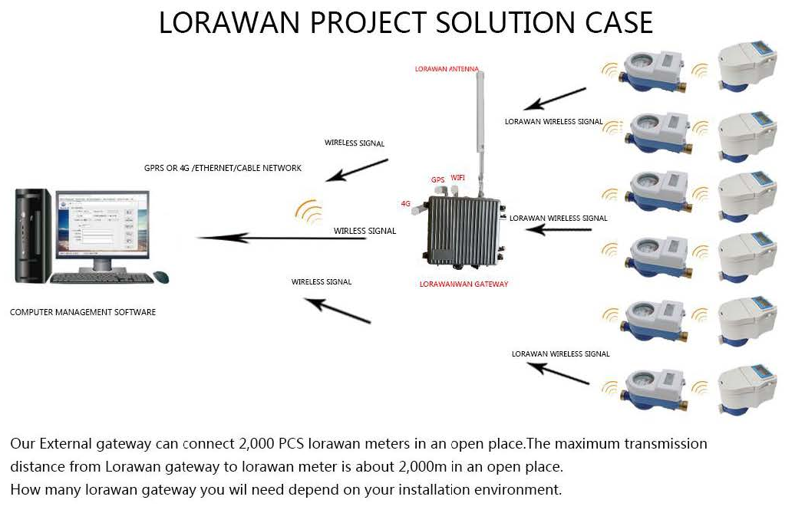

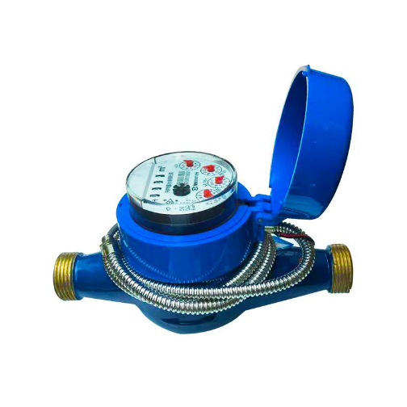**Remote water meter**

* DN15 – DN200
* The photoelectric direct-reading valve-controlled water meter uses the photoelectric direct-reading technology to read the wheel data.
* Compared with the traditional pulse water meter, it can reduce the reading error to zero. It is an electronic remote transmission with zero error of electromechanical conversion in the automatic meter reading system.
* Water meter, with low power consumption design, usually does not need power supply, only need to power it when reading meter or operating valve, solve the problems of users' malicious arrears of taxes and fees, difficult to charge, and realize remote realtime monitoring and remote valve switching and prepayment Fee function.

